How to Solve Problems Using Mathematical Optimization

## Case Study: Bioreactor Bleed Feed

# What is Bleed Feed

## Basics of Bioreactors

|  |  |
| --- | --- |
| **Bioreactor**  IN:  Initial Biomass - Cell Culture  Feed – Substrate  OUT:  Final Biomass  Product from Biomass  Byproducts  CONTROL: pH  Temperature  Oxygen |  |

## Single-Use Bioreactor

Everything that touches product is single use:

* Tubes
* Liners
* Pumps

Expensive, but easier to control process.

Also, short setup times, especially when going from one product to another.

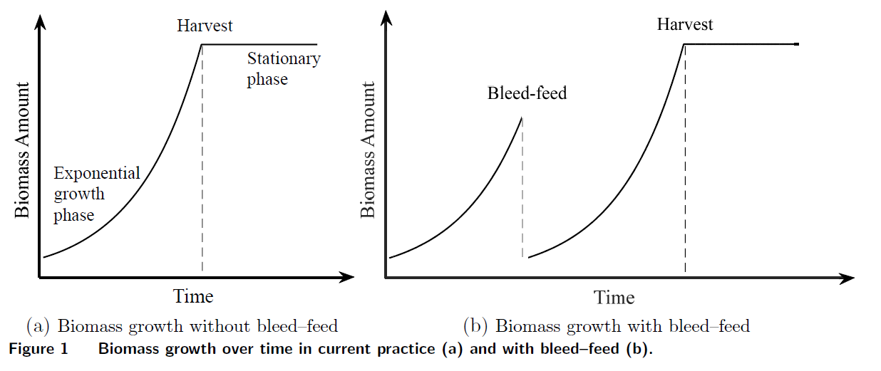

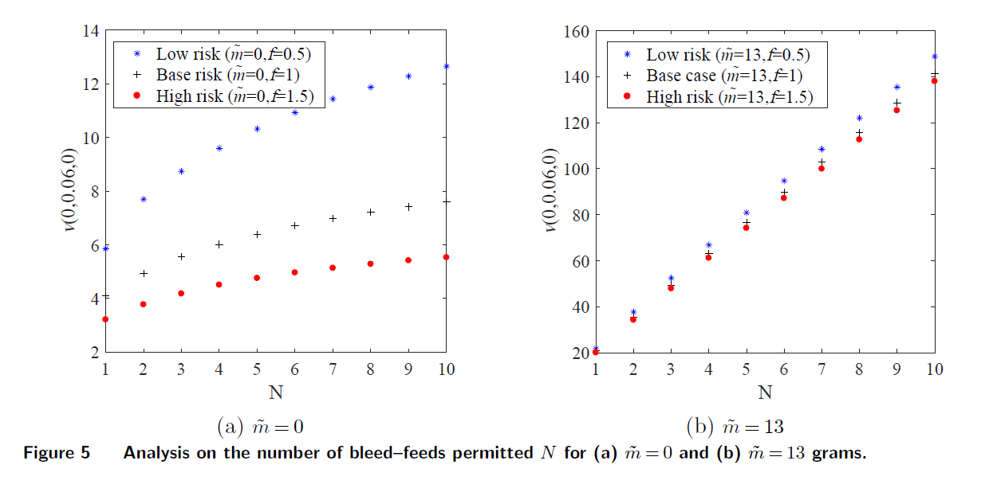

### Bleed-Feed Reduces Numbers of Setups

### Save on Setup Cost (Cost-Based Competition)

Bleed-Feed Production 82% of Baseline without a setup ( Setup, Batch One 100%, BF 82%)

Bleed Feed is difficult to control. Works better on bacteria, but not as well on viruses.

### Save on Setup Time (Time-Based Competition)

Will refrain from talking about this.

# Basic Optimization Modeling

3 Products

2 Bioreactors

Schedule Production for 1 Period

# Stochastic Optimization Modeling

3 Products

2 Bioreactors

Schedule Production for 2 Periods

Unknown Demand (3 scenarios)